This module with a 433Mhz Dorji DRF1278F lora module fitted to a breadboard friendly breakout board. The board will allow you to use the DRF1278F with a standard 0.1” matrix breadbord or stripboard.
The module is supplied with the DRF1278F module and edge SMA antenna connector fitted. The module is supplied with the 0.1" pins unsoldered so leaving you the option of how to assemble or use the board in a project.
The module can be used with a simple wire antenna about 17.5cm long, if you want to do this please add a comment with the order to have the module supplied with the SMA edge socket un-soldered.
This board can be used with the Easy mikroBUS™ Pro Mini controller available in this shop.

Do not operate the DRF1278F module without an antenna. The DRF1278F is a 3.3V supply and logic level device, do not use directly with 5V controller boards such as the Arduino UNO.
The pinout of the board is below, the lora device pin names on the outside.
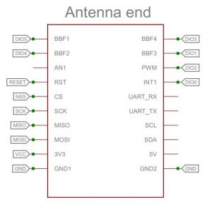
There are many examples for using this module for GPS trackers or sensors provided in an Arduino the library here; https://github.com/StuartsProjects/SX12XX-LoRa

